**Post Earnings Announcement Drift during 2009 to 2017**

Number of distinct firms with positive(good news) and negative(bad news) earnings surprise:

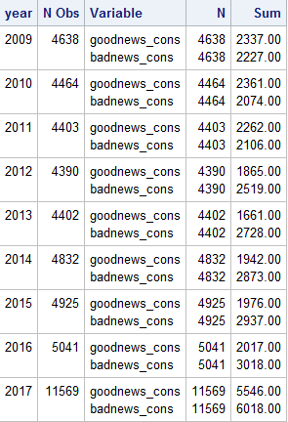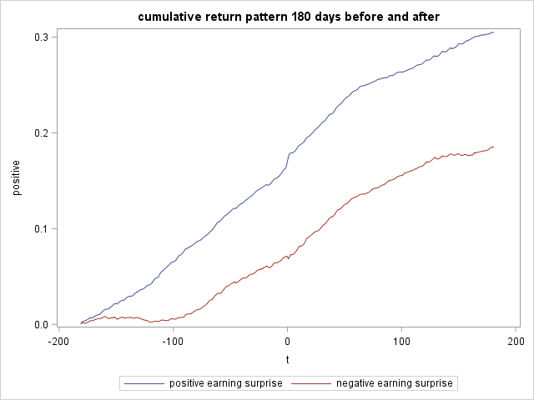

The cumulative returns increase in both cases, but increase faster when there are positive earning surprises than there are negative earning surprises. It shows that market is able to tell whether the firm is doing good or bad based on earning announcement. On the earning announcement date, there is a surge in returns when there is good news and increase in the same direction after announcement, indicating that financial reporting is value relevant and useful. However, it cannot be concluded from the graph that post earning announcement drift also apply to negative earning surprises. This happens probably because of the special time period from 2009 to 2017 after the 2008 financial crisis. The increases in cumulative return started from 181 days before the earning announcement because there were other information and was incorporated into the price.